33A1209151643

Required fields for the Bills Pay Kiosk

1. DESCO (API Connectivity) – Home Page

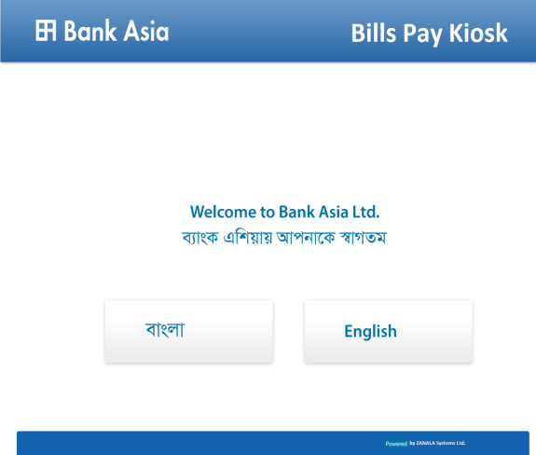

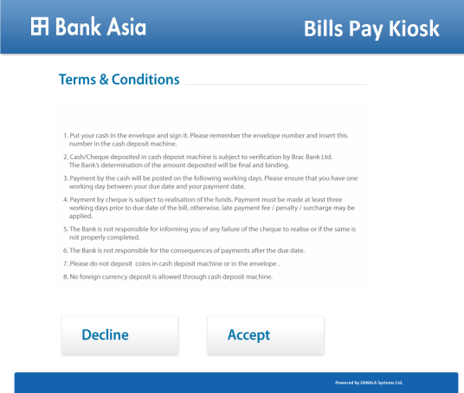

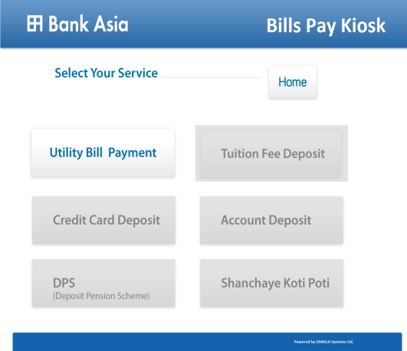

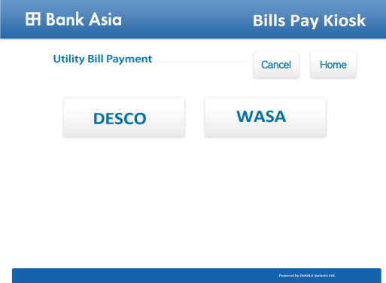

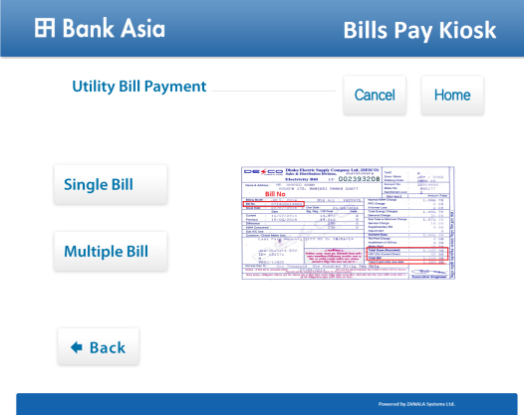

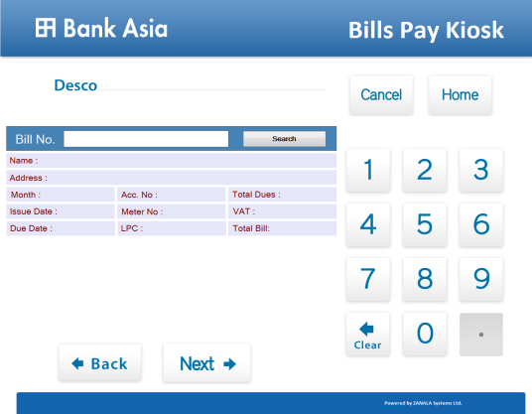

* 1. Insert 12 digit numeric bill number in the Bill No. field box

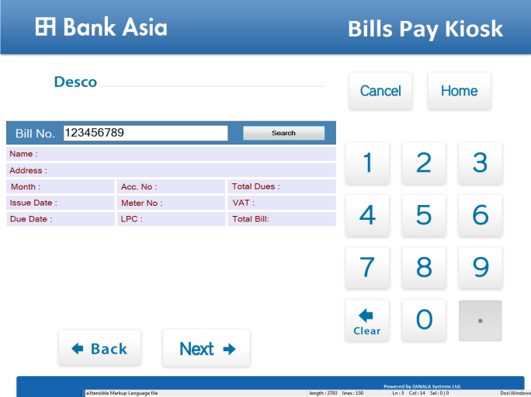

1. After inserting the 12 digits bill number, box will turn green colour.
2. Then press Search button
3. It will retrieve the following information of bills through API
   * + - Name
       - Address
       - Month
       - Issue Date
       - Due Date
       - Acc No
       - Meter No
       - LPC
       - Total Dues
       - VAT
       - Total Bill

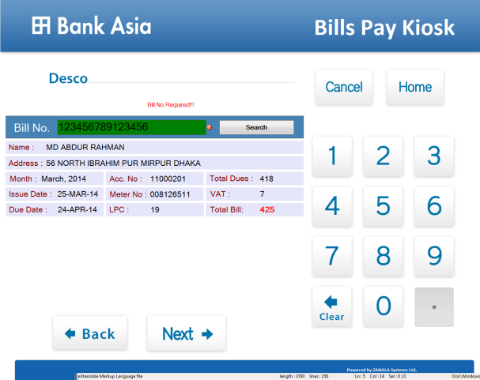

1. Press next button which will view below screen.

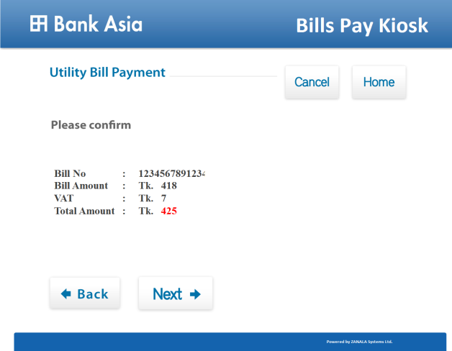

1. Press next button which will view below screen. The system/terminal will generate a 3 digits numeric transaction number daily basis starts from 001.

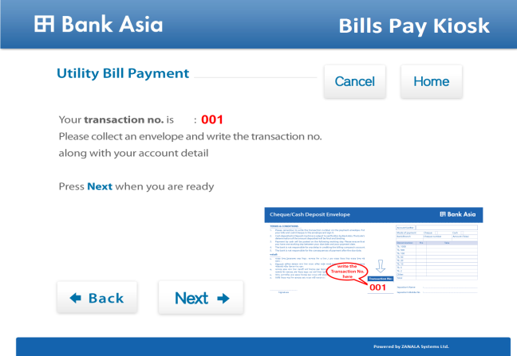

1. Press next button which will view below screen.

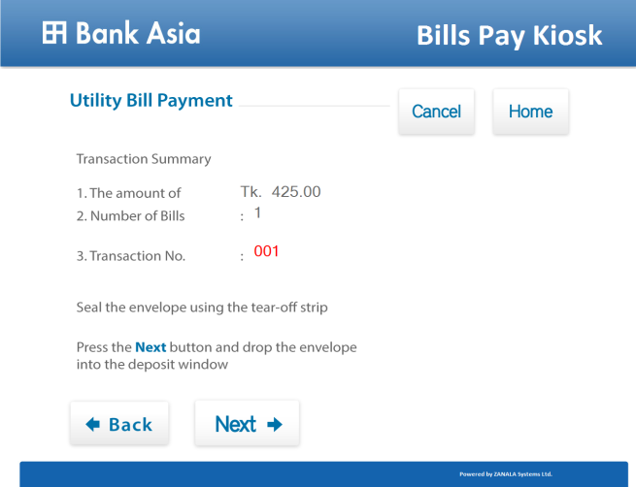

1. Press next button which will view below screen and shutter will open for inserting envelope for 20 seconds count.

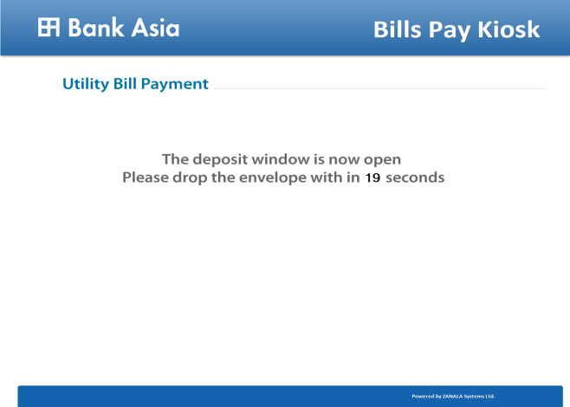

1. After shutter close, printout will come and return to home page.

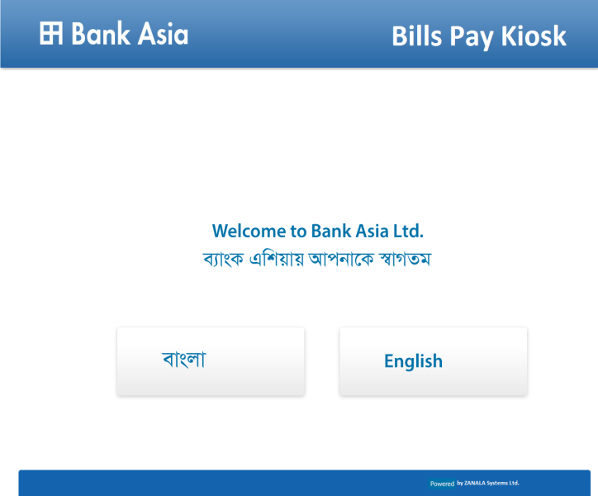

1. Print Receipt will contain below format & information.

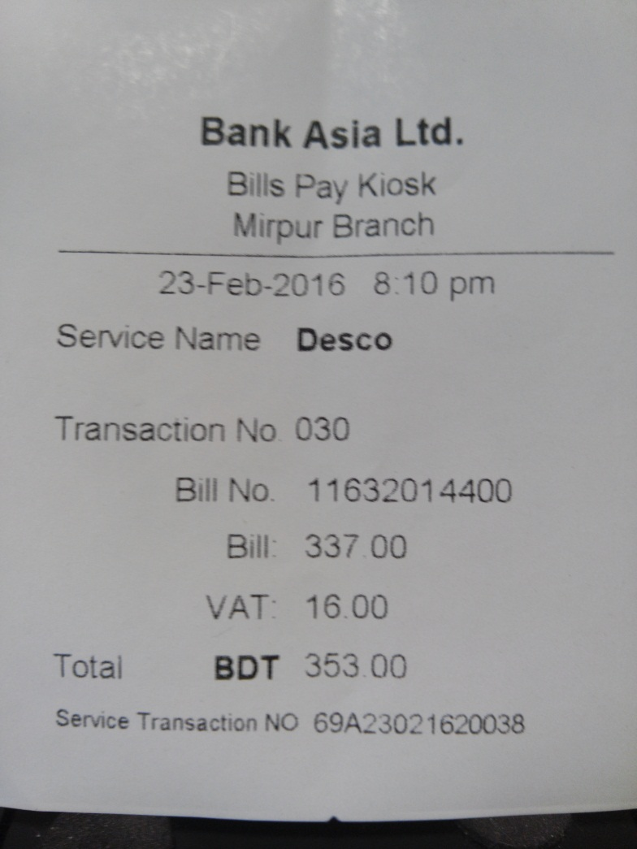

Here service transaction number 69A23021620038 represents -

* 69A – Unique machine code number and will change machine to machine
* 230216 – ddmmyy
* 20 - Hour time means 8pm
* 03 – Minutes time means 03 minutes
* 8 - 1 digit numeric transaction number.

**Notes:**

1. **As we don’t see any utilization of this service transaction number, our suggestion to make this as unique Machine ID for each CDM – 3 digits alpha numeric as Machine ID No. 69A and it will be placed before 1 row of Transaction No.**
2. **Service Name Desco should be in capital letters DESCO or can put the logo**
3. **At last Thank you for the payment will be written at bottom.**

-----------------------------------------------------------------------------------------------------------------------------

For multiple, below screen shots will be followed -

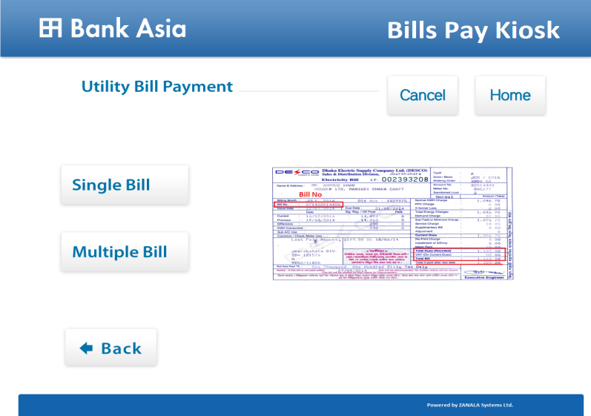

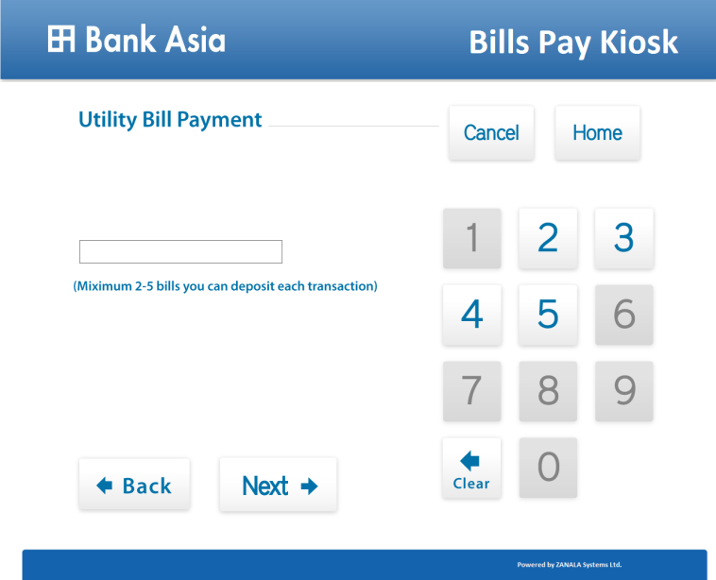

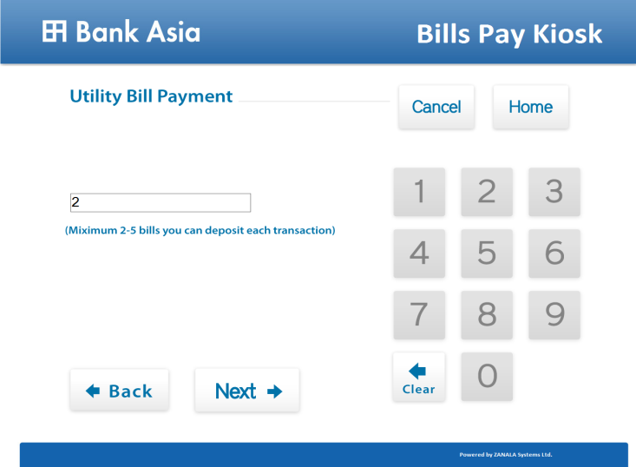

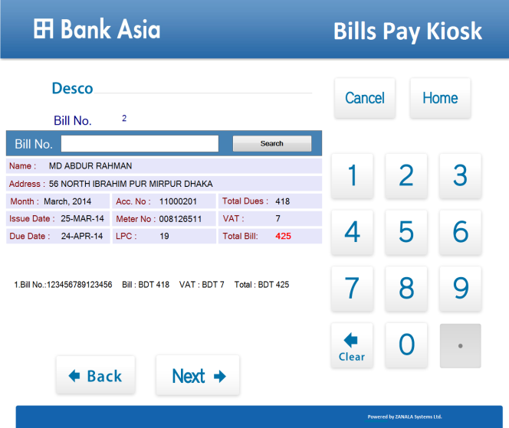

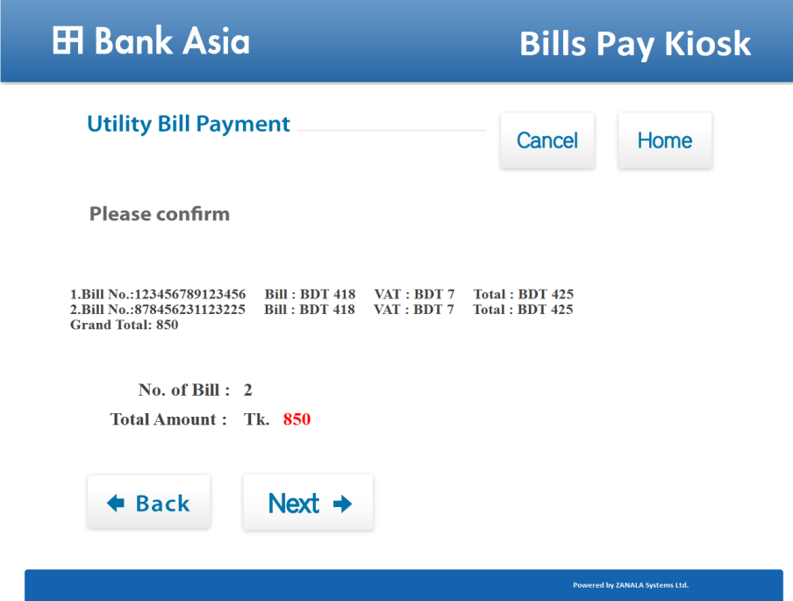

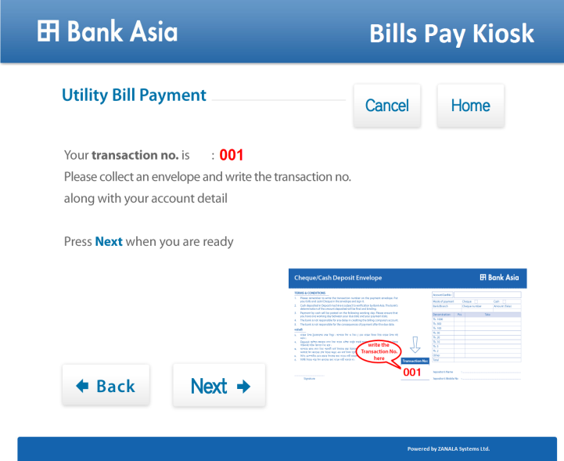

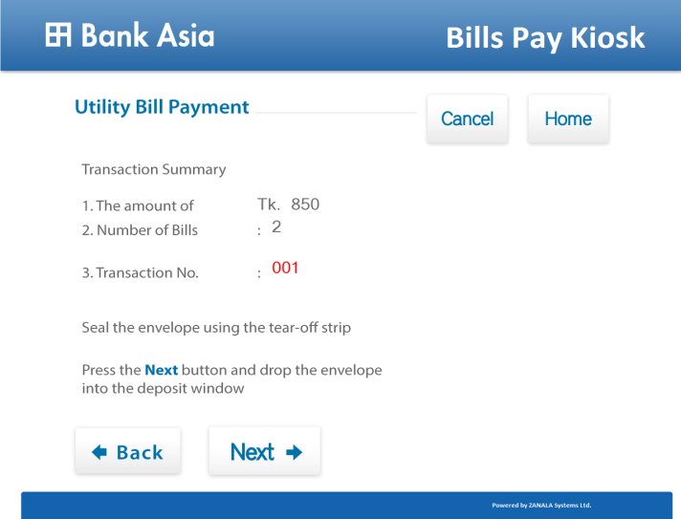

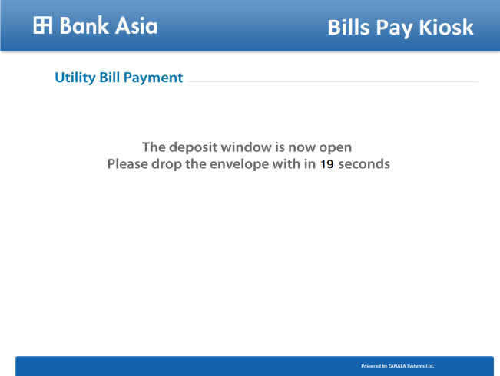

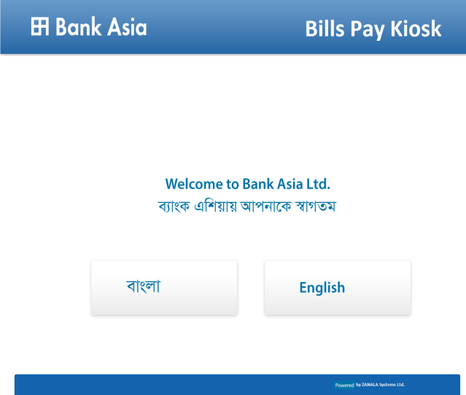

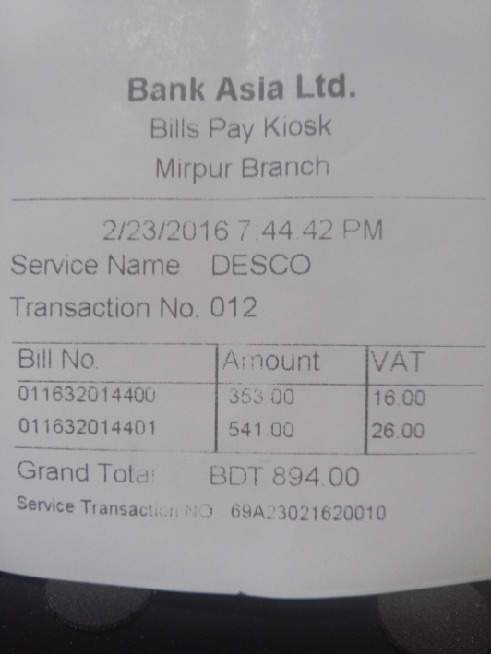

**Notes:**

1. **As we don’t see any utilization of this service transaction number, our suggestion to make this as unique Machine ID for each CDM – 3 digits alpha numeric as Machine ID No. 69A and it will be placed before 1 row of Transaction No.**
2. **Service name DESCO can be replace with logo**
3. **At last Thank you for the payment will be written at bottom.**
4. DPDC (API Connectivity) – Single bill
   1. Insert 7 digit numeric bill number in the Bill No. field box
   2. After inserting the 7 digits bill number, box will turn green colour.
   3. Then press Search button
   4. It will retrieve the following information of bills through API
      * + Name
        + Address
        + Month
        + Issue Date
        + Last Pay Date
        + Customer No.
        + Meter No
        + LPS
        + Principal Amount
        + VAT
        + Total
   5. **Then follow the DESCO process**
   6. **For multiple bills, follow DESCO process**
5. WASA (API Connectivity) – Home Page



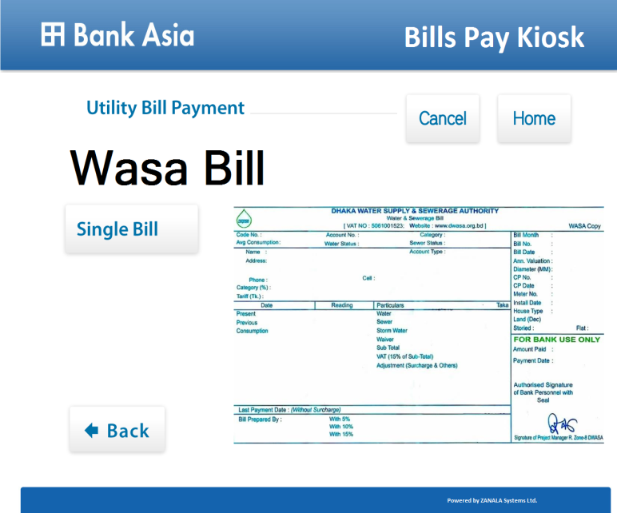

* **Wasa Bill will be written as WASA Bill and in blue colour.**
* **There will be no Single Bill button as WASA always will be single bill.**
* **There will Next button and after pressing next button will appear below –**

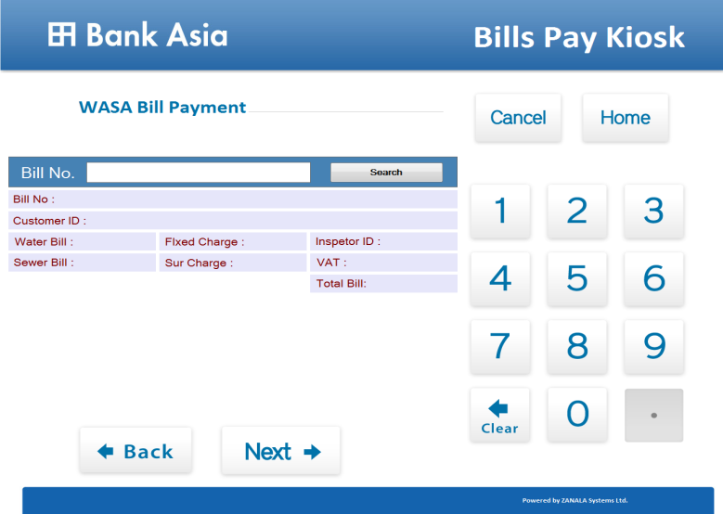

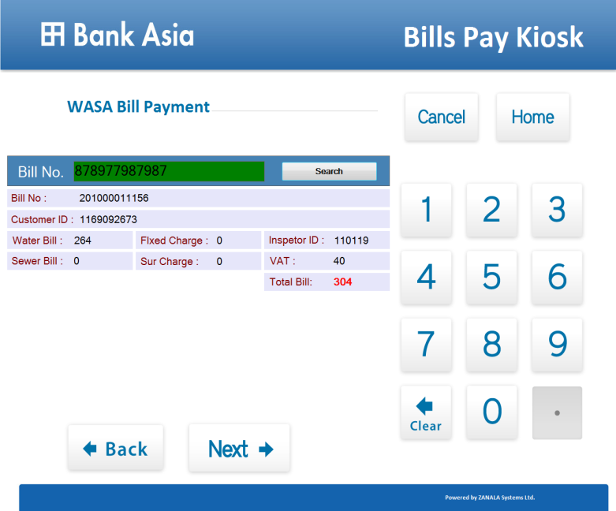

* 1. Insert 12 digits bill number in Bill No. field box
  2. After inserting the 12 digits bill number, box will turn green colour.
  3. Then press Search button
  4. It will retrieve the following information of the bill through API
     + Customer ID
     + Water Bill
     + Sewer Bill
     + Fixed Charge
     + Sur Charge
     + Inspector ID
     + VAT
     + Total Bill

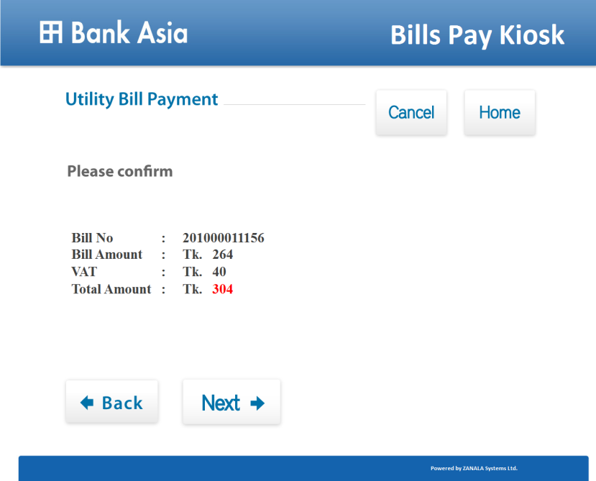

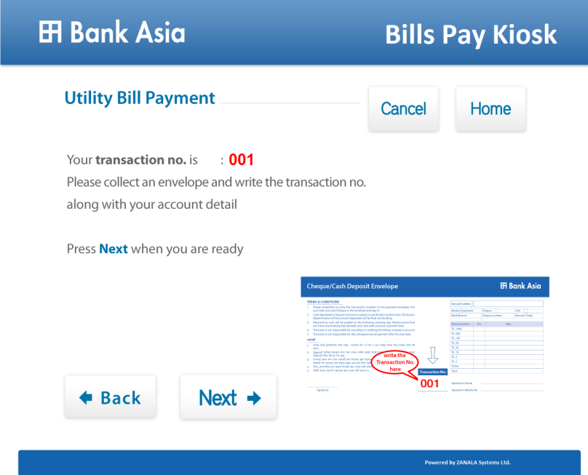

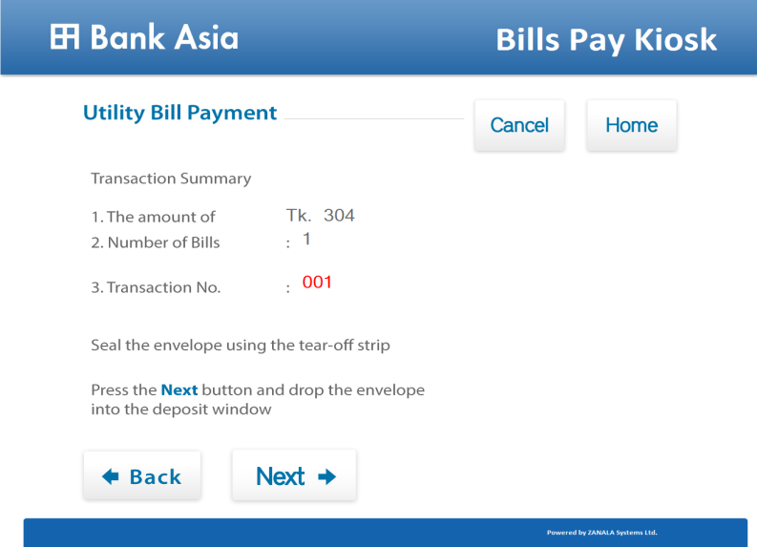

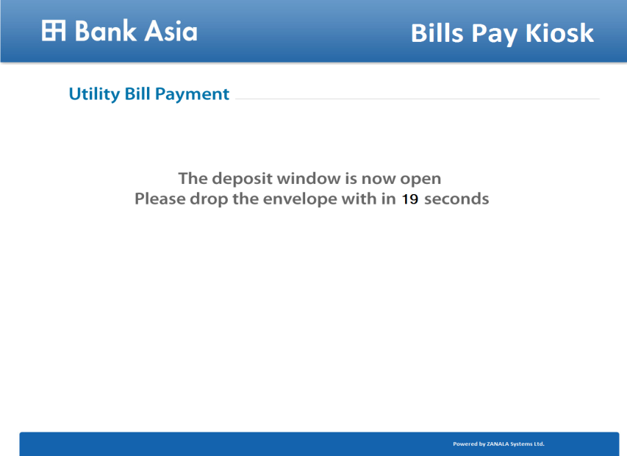

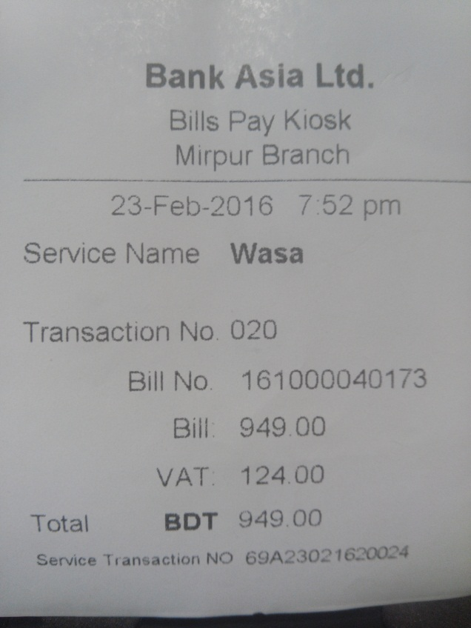

**Notes:**

1. **As we don’t see any utilization of this service transaction number, our suggestion to make this as unique Machine ID for each CDM – 3 digits alpha numeric as Machine ID No. 69A and it will be placed before 1 row of Transaction No.**
2. **Service name Wasa will be capital letters WASA or can be replace with logo**
3. **At last Thank you for the payment will be written at bottom.**
4. Birshreshtha Noor Mohammad Public College (Off-Line)







* 1. Press Tuition Fee Deposit button
  2. Insert 5 digits numeric ID number in the Student ID No. field box
  3. Insert Month from drop down box
  4. Insert 4 digits numeric year in the Year field box
  5. Insert numeric amount in BDT Amount field box - (Maximum 6 digits with auto coma separator in metrics with 2 decimal points)
  6. Press Next button will show the inputted information with Transaction ID like DESCO, DPDC & WASA.
  7. Print receipt will print out like Transaction ID & Machine ID as like as DESCO, DPDC & with Machine ID. However Service name will shorten like BNMPC instead of full college name.

1. HURDCO International School (Off-Line)







1. Press Tuition Fee Deposit button
2. Insert 6 digits numeric ID number in the Student ID No. field box
3. Insert Month from drop down box
4. Insert 4 digits numeric year in the Year field box
5. Insert numeric amount in BDT Amount field box - (Maximum 6 digits with auto coma separator in metrics with 2 decimal points)
6. Press Next button will show the inputted information with Transaction ID like DESCO, DPDC & WASA.
7. Print receipt will print out like Transaction ID & Machine ID as like as DESCO, DPDC & with Machine ID. However Service name will be HURDCO instead of full school name.
8. Independent University, Bangladesh (Off-Line)







1. Press Tuition Fee Deposit button
   1. Insert 7 digits numeric ID number in the Student ID No. field box
   2. Insert Semester from drop down box (Spring, Summer & Fall)
   3. Insert 4 digits numeric year in the Year field box
   4. Insert numeric amount in BDT Amount field box - (Maximum 6 digits with auto coma separator in metrics with 2 decimal points)
   5. Press Next button will show the inputted information with Transaction ID like DESCO, DPDC & WASA.
   6. Print receipt will print out like Transaction ID & Machine ID as like as DESCO, DPDC & with Machine ID. However Service name will be IUB instead of full university name.
2. East West University (Off-Line)







* 1. Press Tuition Fee Deposit button
  2. Insert 10 digits numeric ID number in the Student ID No. field box
  3. Insert Semester from drop down box (Spring, Summer & Fall)
  4. Insert 4 digits numeric year in the Year field box
  5. Insert numeric amount in BDT Amount field box - (Maximum 6 digits with auto coma separator in metrics with 2 decimal points)
  6. Press Next button will show the inputted information with Transaction ID like DESCO, DPDC & WASA.
  7. Print receipt will print out like Transaction ID & Machine ID as like as DESCO, DPDC & with Machine ID. However Service name will be EWU instead of full university name.

1. North South University (Off-Line)







* 1. Press Tuition Fee Deposit button
  2. Insert 10 digits numeric ID number in the Student ID No. field box
  3. Insert Semester from drop down box (Spring, Summer & Fall)
  4. Insert 4 digits numeric year in the Year field box
  5. Insert numeric amount in BDT Amount field box - (Maximum 6 digits with auto coma separator in metrics with 2 decimal points)
  6. Press Next button will show the inputted information with Transaction ID like DESCO, DPDC & WASA.
  7. Print receipt will print out like Transaction ID & Machine ID as like as DESCO, DPDC & with Machine ID. However Service name will be NSU instead of full university name.

1. Viqarunnisa Noon School & College (Off-Line)

Not yet decided

1. **Session Close Report**

|  |  |
| --- | --- |
| **BANK ASIA LTD.**  **ZANALA Bills Pay Kiosk**  **<Branch Name>**  **Session Close Report**  **ddmmyyyy (06-March-2016) 7:52pm (Time)** | |
| **CDM ID No.: <69A>** | |
| **Last Session Close Date & Time: <05-March-2016>, <7:52pm>** | |
| **Total Transaction: <numeric number>** | |
|  | **DESCO - <numeric number>**  **DPDC - <numeric number>**  **WASA - <numeric number>**  **BNMPC - <numeric number>**  **HURDCO - <numeric number>**  **EWU - <numeric number>**  **NSU - <numeric number>**  **IUB - <numeric number>** |
| **Total Amount: BDT<amount>** | |

1. **Daily Report (Excel)**

|  |  |  |  |  |  |  |  |  |  |  |  |  |  |
| --- | --- | --- | --- | --- | --- | --- | --- | --- | --- | --- | --- | --- | --- |
| **Serial No.** | **Date** | **CDM ID** | **Branch/Booth** | **Zone** | **Transaction No.** | **Payment Type** | **Bill/Student ID/CC/AC/DPS/SP Number** | **Institution** | **Month or Semester** | **Year** | **Amount** | **VAT** | **Total Amount** |
| 01 |  | 69A | Mirpur-1 | Dhaka |  | Utility |  | DESCO | March |  |  |  |  |
| 02 |  | 69A | Mirpur-1 | Dhaka |  | Utility |  | DPDC | March |  |  |  |  |
| 03 |  | 69A | Mirpur-1 | Dhaka |  | Utility |  | WASA | March |  |  |  |  |
| 04 |  | 69A | Mirpur-1 | Dhaka |  | Fees |  | ­­­­­­­­­­­­­­ | March |  |  |  |  |
| 05 |  | 69A | Mirpur-1 | Dhaka |  | Fees |  | HURDCO | March |  |  |  |  |
| 06 |  | 69A | Mirpur-1 | Dhaka |  | Fees |  | EWU | Spring |  |  |  |  |
| 07 |  | 69A | Mirpur-1 | Dhaka |  | Fees |  | NSU | Spring |  |  |  |  |
| 08 |  | 69A | Mirpur-1 | Dhaka |  | Fees |  | IUB | Spring |  |  |  |  |
| **Total** | | | | | | | | | | |  |  |  |

It will be saved in the CDM terminal date wise and will copy in pen drive from CDM terminal. Table text direction changed due to space constraint but actually it will like red colour direction.